**Github website:** [**https://mattrmit.github.io/Assignment1/**](https://mattrmit.github.io/Assignment1/)

**Github repository:** [**https://github.com/Mattrmit/Assignment1**](https://github.com/Mattrmit/Assignment1)

**Personal information**

My name is Matthew and I am 21, I am an online student at RMIT(**Student no. s3950819).** My student email is [**s3950819@student.rmit.edu.au**](mailto:s3950819@student.rmit.edu.au). 

I live in the regional part of South Australia on the Yorke Peninsula. I have lived in Australia all my life and I have never left! One day I hope to explore other countries as living in one place for all your life isn’t something I am interested in.

I moved to the Yorke Peninsula in 2016 for a change of pace as my dad became unwell. I am a bit of a nerd, I have been playing games online and singleplayer for all my life and I have a very nerdy father and brother. They both got me into gaming and computers in general at a very young age. My very first game that I remember playing is Super Mario 64 on the Nintendo 64.

I played sports all throughout my schooling (Soccer, Basketball and a bit of Football). I am an extreme animal lover. I believe animals are more than just pets. I have three cats that are mine and a family dog. I have had at least one animal at a time throughout my life and I wouldn't change a thing.

My interest in IT came from my Dad, as he worked in the IT industry for all of his working career. He started as a Telstra technician way back when they were first setting up mobile towers. He has always been around computers, my interest definitely was inspired by him. As well as my dad, my brother has also had a large impact on that inspiration as well. He is the one that got me into gaming and thus further cemented my desire to work in the IT industry.

I chose to study at RMIT as it allowed for a broad approach to learning and because I live remotely, RMIT allowed me to study online. I am excited to learn as much as I can about the IT industry as I can, hopefully allowing me to reach my goals.

**Ideal Job**

[**https://www.seek.com.au/job/56041869?type=promoted#sol=e3b4f831b400af527ad8ac538737c9114bd022fb**](https://www.seek.com.au/job/56041869?type=promoted#sol=e3b4f831b400af527ad8ac538737c9114bd022fb)

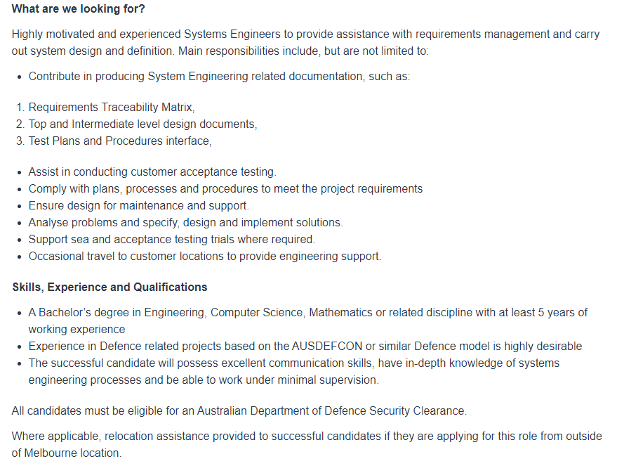

This job requires a lot of experience. However, this is something that has generally been what has inspired me to work in IT. It's not set in stone if this is what I’ll end up doing but it is at the moment, but could change by the time I finish this course.

This job would allow me to provide defence to cyber domains. Allowing me to develop systems that assist in safety which I think is pretty cool!

The skills required are pretty high, as you generally need a degree in computer science or something along the lines of that. You need to be able to obtain the Australian Department of Defence Security Clearance for this job in particular.

I plan on finishing this course and then depending on if I am still set to do this job I would seek more qualifications to help me assist in gaining this type of employment. However, I would also seek a different job for more experience while I am continuing my study for Cyber security.

**Personal Profile:**

<https://www.16personalities.com/isfp-personality>

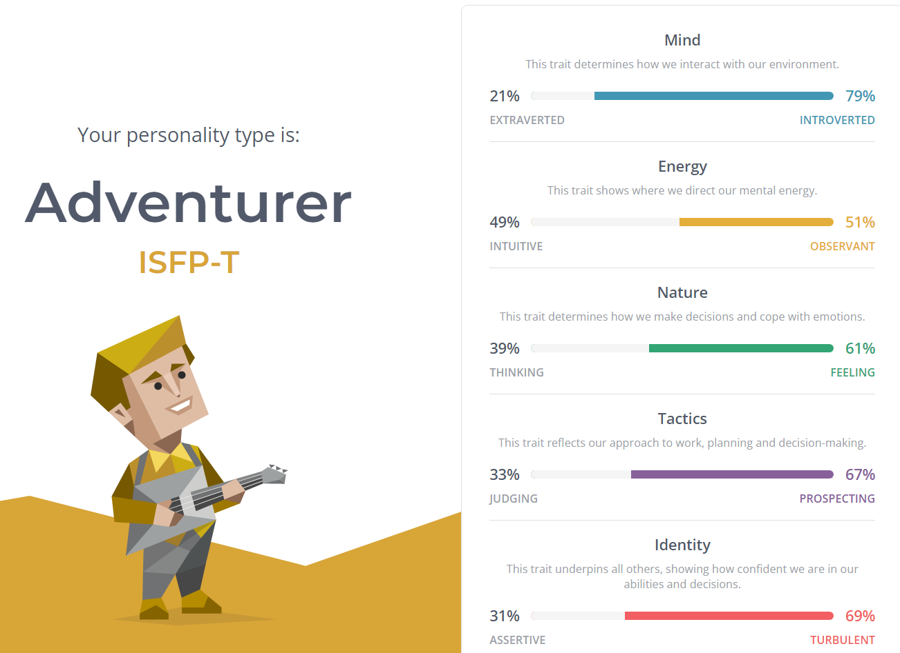

<https://vark-learn.com/the-vark-questionnaire/?p=results>

[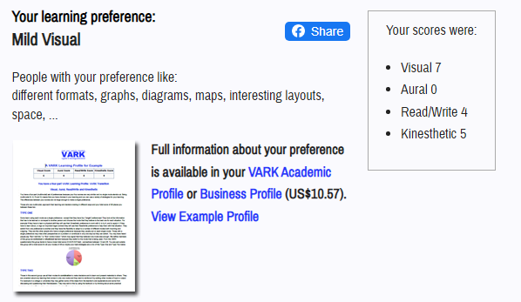](https://vark-learn.com/the-vark-questionnaire/?p=results)

<https://www.truity.com/test-results/bigfive/17315/28997534> 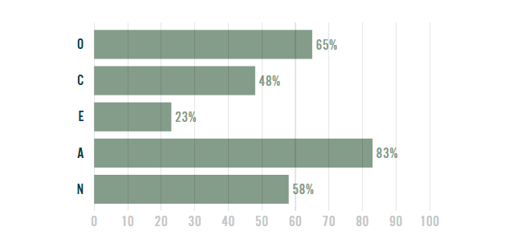

These results would influence my behaviour in a team as I am quite a shy person. Allowing other people ideas over my own. I find that I have more time for other people than myself. However, when given the chance, I am able to give my personal input on what I believe the team should be doing.

When forming a team I prefer to follow a group rather than lead, so having a good team leader within a group environment is essential for me. I have no issues with being told what to do unless a decision is made on something I strongly disagree with.

**IT Project Idea**

Rdelivery is my project idea, and it allows local businesses to set up delivery in regional and remote areas by utilising a website and its associated app. Rdelivery will help remote businesses promote their reputation and deliver quality products to customers as customers have varying capability of accessing and communicating with businesses.

Alike 28% of Australia’s population, I live in a remote area where there are limited delivery options available for small businesses and so there is a large market for this type of service. Regional locations make getting deliveries rather difficult when the item you order needs to be delivered to your house such as take-away, groceries, or even small items from stores within towns. Deliveroo is the closest regional delivery service we have in my town, disregarding the national post. However, Deliveroo does not deliver outside of the town in which they operate. Rdelivery would be more inclusive and not locked to just take-away food, but rather, anything that someone wants delivered within reason. Rdelivery allows people to order anywhere even if they are not home.

This name Rdelivery is not confirmed but just a placeholder. The website of this service would be mainly for businesses, small or large to sign up to the service. Age wouldn’t necessarily be a factor but people under the age of 18 would need parental approval. We wouldn’t want to stop young entrepreneurs from their dreams. This would allow even the really small start-up businesses to still get going. The website wouldn’t just be for signing up to the service though, this is also where we would review driver applications. To improve local jobs we would hire local drivers to deliver products. Drivers would have a car inspection and a background check just like other delivery companies, ensuring the safety of not only the driver, product, and customer but also helps us legally. However, why just limit the website to that? It would also be an idea to set up a store-like user interface. This would allow people to view all the connected stores which promotes ease of access.

Rdelivery’s main focus is providing an affordable delivery service that is trustworthy and reliable. Rdelivery with prioritise informing the customer who the driver is by showing their profile with information approved by the driver and a GPS-tracked estimated delivery time. Rdelivery would aim to deliver bigger products on the same day but this would depend on the number of available drivers and customer location. For example, when Rdelivery is in high demand the wait time may be a few days but smaller products such as food would have their own category and thus, a reduced wait time of regardless of user fluctuation. Furthermore, Rdelivery would have its own store section on the phone app to promote user-friendliness. Each store would have their own website embedded within the app so that when you click your store to browse it brings up the available products in a timely and convenient manner.

Customer satisfaction and experience is a vital consideration of Rdelivery’s service and thus, there will be a rating feature available to gather feedback on the drivers’ and the store’s products. This might look like a satisfaction rating based on, but not only, delivery time, and overall friendliness of the service. We want to be able to gather customer complaints with relative ease as we can make changes when required that will benefit the customer in the more efficient way possible. Studies show that shoppers are 80% more likely to revisit and purchase products from services that offer personal and individual experience, at Rdelivery, customers will be provided with personal updates and driver-interactions to provide information on the current situation of their deliveries.

To develop the website we would need a tool to help assist in this such as a software program similar to Adobe XD for example. This tool is user-friendly in web design and would allow ease of creativity when it comes to website development. There is a free or paid option. Since Adobe XD is owned by Adobe it runs extremely well with other Adobe programs which allows for even easier integration if required when creating this website. For the app I could use the tool Appery.io, this tool is purely for phone app (IOS or Android) development. It has a low-code requirement allowing new or old programmers ease of access. Although it has a low-code requirement, it allows you to write source code editing which would be very useful when developing an app of this size and structure.

Although the programs aforementioned can assist with my website they are just baselines, I have never used them personally; thus, I would have to test them to prove whether or not they will be sufficient. However, the reviews and summaries of these programs are rigorous, promising, and well reviewed by users. There are a lot of development programs out there that would assist the app and website of this service. Finding the tools required to create a remote delivery service will be challenging but a worthwhile endeavour to allow remote business access to a larger network.

If the project gained popularity it would allow businesses of all sizes to thrive in the regional environment regardless of where they are geographically located. If Rdelivery is successful it would allow businesses to promote their brand online as we would have their website visible on the app. Rdelivery solves the lacking options of delivery services for regional locations by providing a website that can establish access to an online network available to all regional areas. As Rdelivery gains traction you expect to see an influx of economic growth in small businesses located in regional areas as they will become visible to the online world.

Reference list

Australian Institute of Health and Welfare (2020). *Rural and remote health*. [online] Australian Institute of Health and Welfare. Available at: <https://www.aihw.gov.au/reports/australias-health/rural-and-remote-health> [Accessed 18 Mar. 2022].

NERIS Analytics Limited (2011). *16 Personalities*. [online] 16personalities.com. Available at: <https://www.16personalities.com/> [Accessed 18 Mar. 2022].

Truity. (n.d.). *The Big Five Personality Test*. [online] Available at: <https://www.truity.com/test-results/bigfive/17315/28997534> [Accessed 18 Mar. 2022].

VARK (2020). *VARK Questionnaire*. [online] VARK - A Guide to Learning Preferences. Available at: <https://vark-learn.com/the-vark-questionnaire/?p=results> [Accessed 18 Mar. 2022].

W3Schools (2018). *HTML Tutorial*. [online] W3schools.com. Available at: https://www.w3schools.com/html/ [Accessed 18 Mar. 2022].